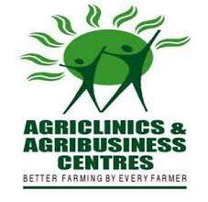 | 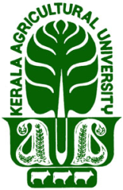 | REGIONAL AGRICULTURAL RESEARCH STATION  KERALA AGRICULTURAL UNIVERSITY | 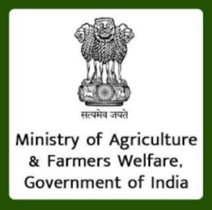

ADMISSION FOR AGRI CLINICS AND AGRI BUSINESS CENTRE(AC&ABC) COURSE AT RARS, PATTAMBI, KERALA AGRICULTURAL UNIVERSITY(KAU)

Regional Agricultural Research Station, Pattambi, KAU invites application from eligible candidates for a Training Programme under Agri-Clinic and Agri –Business Centers Scheme of Ministry of Agriculture, Government of India
About the training programme
Agri-Clinic and Agri –Business Centre Scheme (AC & ABC) is implemented by the Ministry of Agriculture & Farmer’s Welfare, Government of India since April, 2002 with the support of National Institute of Agriculture Extension Management (MANAGE),an autonomous organization under the Ministry of Agriculture & Farmer’s Welfare, Government of India.
The objective and Salient features of the scheme :
- To promote agri entrepreneurship and create gainful self-employment opportunities
- To supplement the efforts of Public extension.
As per the guidelines of the AC&ABC scheme 45 days training will be imparted to the selected candidates on various aspects related to agriculture and entrepreneurship development. After the 45 days training, the candidates have to submit their projects for obtaining bank loan for establishing agricultural ventures. The bank will provide loan after the thorough scrutiny of the project submitted by the candidate.
Age | : | 21 to 60 years
Training period | : | 45 days free residential programme.
Type of project | : | Individual and group projects under Agriculture/ Allied sectors
Margin money | : | No margin money up to Rs. 5 Lakhs. 10-15 % or as decided by the Banks.
Rate of interest | : | As decided by Bank (commercial bank/ Private/ RRB/ cooperative Banks)
Security | : | Collateral Security up to a loan amount of Rs. 5 lakh is waived. Hypothetication of assets, mortgage of lands or third party guarantee.
Repayment period | : | 5-10 years, depends on the project.
Handholding | : | Post-training up to one year.
Subsidy | : | Ceiling of project cost for subsidy is up to Rs. 20 lakh (Individual) and Rs. 100 lakh (for a group project comprising at least 5 trained persons)
Eligibility for Training:Graduates in Agriculture and allied subjects like Horticulture, Sericulture, Dairy, Animal Husbandry, Fisheries, Home/ Community Sciences, Biotechnology, Agricultural Engineering, Forestry, Food Technology, Food Nutrition and Dietetics etc., from SAUs/ Central Agricultural Universities/ Universities and graduates in Environmental Science, Botany, Zoology and Chemistry recognized by ICAR/ UGC. Degree in Agriculture and allied subjects offered by other agencies are also considered subject to approval of Department of Agriculture & Farmers Welfare, Government of India on recommendation of the State Government. or Diploma in Agriculture with at least 50% marks.
NOTE: The training course mentioned above is not a guarantee for availing of the loan. Sanctioning of the loan would be on the basis of the techno-economic viability of the project submitted.
Application Process
- Interested candidate submit the application form online ( see the website https://acabcmis.gov.in/ApplicantReg.aspx)
- Please enter all the requisite details in the application form. Incomplete application forms are liable to be rejected.
- Please send a copy of the form submitted online to the address mentioned below along with photocopy of certificate of qualification acquired.
- Please superscribe in bold letters on the envelope “APPLICATION FOR AC&ABC”.
- Candidates are required to pay an application fee(Non Refundable) of Rs. 500/- (Rupees five hundred only) at the time of interview.
- The tentative date of screening for training will be July 2025(First week) and the training will start on July 2025(last week). For any further clarification regarding course please contact the Nodal officer, Regional Agricultural Research Station (RARS), Pattambi. Email: bs.sundaram@kau.in

